**Code Outputs**

**Choice: 1 Use EMA to computerise MACD trading**

Date Close

0 2016-01-04 201.02

1 2016-01-05 201.36

2 2016-01-06 198.82

3 2016-01-07 194.05

4 2016-01-08 191.92

... ... ...

1506 2021-12-27 477.26

1507 2021-12-28 476.87

1508 2021-12-29 477.48

1509 2021-12-30 476.16

1510 2021-12-31 474.96

[1511 rows x 2 columns]

Enter choice to use EMA (expotential moving average) or SSMA (Standard Simple Moving Average):

1

The SEMA column is:

0 201.02

1 201.07

2 200.73

3 199.70

4 198.50

...

1506 466.80

1507 468.35

1508 469.75

1509 470.74

1510 471.39

Name: Close, Length: 1511, dtype: float64

The LEMA column is:

0 201.02

1 201.05

2 200.88

3 200.37

4 199.75

...

1506 464.64

1507 465.54

1508 466.43

1509 467.15

1510 467.73

Name: Close, Length: 1511, dtype: float64

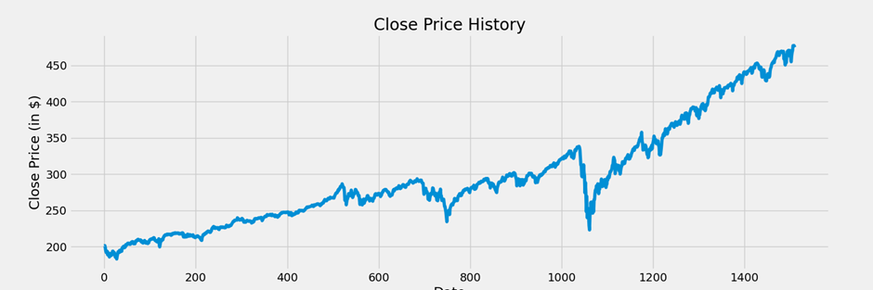

Date Close SEMA LEMA MACD line Signal line Buy_Signal_price Sell_Signal_price NetGain

0 2016-01-04 201.02 201.02 201.02 0.00 0.00 NaN NaN NaN

1 2016-01-05 201.36 201.07 201.05 0.02 0.00 201.36 NaN -226.53

2 2016-01-06 198.82 200.73 200.88 -0.15 -0.03 NaN 198.82 -52.56

3 2016-01-07 194.05 199.70 200.37 -0.67 -0.16 NaN NaN NaN

4 2016-01-08 191.92 198.50 199.75 -1.25 -0.37 NaN NaN NaN

... ... ... ... ... ... ... ... ... ...

1506 2021-12-27 477.26 466.80 464.64 2.16 1.38 NaN NaN NaN

1507 2021-12-28 476.87 468.35 465.54 2.81 1.67 NaN NaN NaN

1508 2021-12-29 477.48 469.75 466.43 3.32 2.00 NaN NaN NaN

1509 2021-12-30 476.16 470.74 467.15 3.59 2.32 NaN NaN NaN

1510 2021-12-31 474.96 471.39 467.73 3.66 2.58 NaN NaN NaN

[1511 rows x 9 columns]

Summary of code run:

The total number of trades is 133

The average return per trade is -2300.01

The relative gain/loss against the long term Buy-Hold-Sell strategy is -167174.68%

1508 2021-12-29 477.481509 2021-12-30 476.161510 2021-12-31 474.96

[1511 rows x 2 columns]

Enter choice to use EMA (exponential moving average) or SSMA (Standard Simple Moving Average):

1

The SEMA column is:

0 201.02

1 201.07

2 200.73

3 199.70

4 198.50

...

1506 466.80

1507 468.35

1508 469.75

1509 470.74

1510 471.39

Name: Close, Length: 1511, dtype: float64

The LEMA column is:

0 201.02

1 201.05

2 200.88

3 200.37

4 199.75

...

1506 464.64

1507 465.54

1508 466.43

1509 467.15

1510 467.73

Name: Close, Length: 1511, dtype: float64

Date Close SEMA LEMA MACD line Signal line Buy_Signal_price Sell_Signal_price NetGain

0 2016-01-04 201.02 201.02 201.02 0.00 0.00 NaN NaN NaN

1 2016-01-05 201.36 201.07 201.05 0.02 0.00 201.36 NaN -226.53

2 2016-01-06 198.82 200.73 200.88 -0.15 -0.03 NaN 198.82 -52.56

3 2016-01-07 194.05 199.70 200.37 -0.67 -0.16 NaN NaN NaN

4 2016-01-08 191.92 198.50 199.75 -1.25 -0.37 NaN NaN NaN

... ... ... ... ... ... ... ... ... ...

1506 2021-12-27 477.26 466.80 464.64 2.16 1.38 NaN NaN NaN

1507 2021-12-28 476.87 468.35 465.54 2.81 1.67 NaN NaN NaN

1508 2021-12-29 477.48 469.75 466.43 3.32 2.00 NaN NaN NaN

1509 2021-12-30 476.16 470.74 467.15 3.59 2.32 NaN NaN NaN

1510 2021-12-31 474.96 471.39 467.73 3.66 2.58 NaN NaN NaN

[1511 rows x 9 columns]

Summary of code run:

The total number of trades is 133

The average return per trade is -2300.01

The relative gain/loss against the long term Buy-Hold-Sell strategy is -167174.68%

**Choice: 2 Use SSMA to computerise MACD trading**

Date Close

0 2016-01-04 201.02

1 2016-01-05 201.36

2 2016-01-06 198.82

3 2016-01-07 194.05

4 2016-01-08 191.92

... ... ...

1506 2021-12-27 477.26

1507 2021-12-28 476.87

1508 2021-12-29 477.48

1509 2021-12-30 476.16

1510 2021-12-31 474.96

[1511 rows x 2 columns]

Enter choice to use EMA (exponential moving average) or SSMA (Standard Simple Moving Average):

2

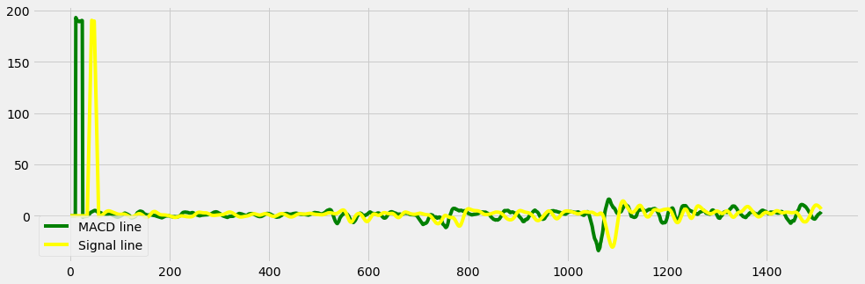

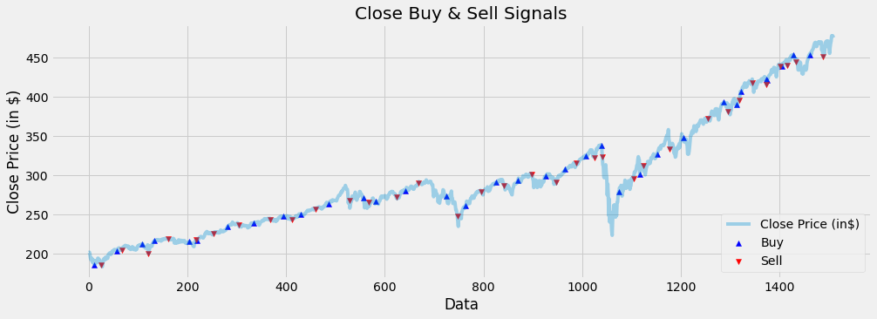

Date Close MACD line Signal line Buy_Signal_price \

0 2016-01-04 201.02 0.00 0.00 NaN

1 2016-01-05 201.36 0.00 0.00 NaN

2 2016-01-06 198.82 0.00 0.00 NaN

3 2016-01-07 194.05 0.00 0.00 NaN

4 2016-01-08 191.92 0.00 0.00 NaN

... ... ... ... ... ...

1506 2021-12-27 477.26 1.91 8.78 NaN

1507 2021-12-28 476.87 2.51 8.27 NaN

1508 2021-12-29 477.48 2.74 7.72 NaN

1509 2021-12-30 476.16 3.21 7.15 NaN

1510 2021-12-31 474.96 3.91 6.47 NaN

Sell_Signal_price NetGain

0 NaN NaN

1 NaN NaN

2 NaN NaN

3 NaN NaN

4 NaN NaN

... ... ...

1506 NaN NaN

1507 NaN NaN

1508 NaN NaN

1509 NaN NaN

1510 NaN NaN

[1511 rows x 7 columns]

Summary of code run:

The total number of trades is 68

The average return per trade is -1254.51

The relative gain/loss against the long term Buy-Hold-Sell strategy is -46238.12%

​